
Majlis Ugama Islam Singapura

Friday Sermon

21 August 2015 / 6 Zulkaedah 1436
Misunderstood Concepts of Al-Wala’ wal Bara’
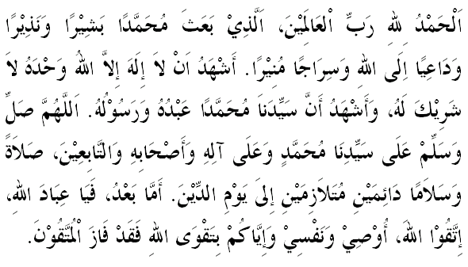
Dearest Friday Congregation,
On this blessed Friday, let us strive to increase our taqwa to Allah s.w.t. by obeying His command and abstaining from what he has prohibited upon us. Let us repent to Allah for our sins and wrongdoings and return to Him with sincere hearts. May Allah s.w.t. accept our repentance and good deeds. Amin

My brothers,
As many previous khutbahs have reiterated, key to uplifting our iman and improving our religious life is knowledge. Knowledge that is derived from trustworthy and credible sources, and that inspires us to develop ourselves and our community. But like with any kind of knowledge, not all aspects of our religion are easy to comprehend. Amongst these, some aspects have developed historically, and are thus very complex. Others may be contextual, and require care and deep reflection before they could be applied in our lives. We need guidance. And in light of the ease of access to all sorts of interpretations, we need to be particularly vigilant of ideas that have been misappropriated with the intent to misguide and destroy. As we move forward as a community that seeks to be contributive to the world and exemplary in its understanding and practice of Islam, we therefore need a certain level of sophistication in assessing our understanding of religious ideas and concepts.

Dear brothers,
Today, I would like to begin with one particular concept in Islam. But before that, I would like to ask you to reflect. Look around us. Do we live on our own, just within our community? Do we have fundamental problems living alongside others in a multi-religious society? Certainly not. Is this comfort in living alongside others and contributing as a society part of the teachings of Islam? The answer has to be a resounding yes. As an example, listen to what Allah s.w.t. says in surah Al-Mumtahinah, verse 8:
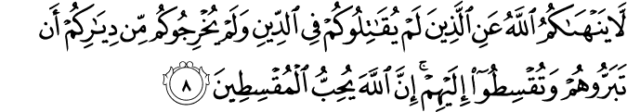
Which means: “Allah (does) not forbid you from those who (do) not fight you in the religion and (do) not drive you out of your homes that you deal kindly and deal justly with them. Indeed, Allah loves those who act justly”.

According to this verse, if Muslims do not find themselves caught in a war waged against them because of their faith, then Allah s.w.t. commands us to uphold kindness and justice to everyone. Alhamdulillah, we could say with confidence that we have upheld this teaching. Muslims in Singapore have always been able to live peacefully and cohesively as part of the larger Singaporean society. We have contributed to the development of our society and continue to do so while practising our religious teachings confidently as Muslims. This signifies our deep conviction to our faith, which at the same time, generates in us the spirit of doing and spreading goodness.

But with the internet and social media, we do hear ideas floating around that seek to break Muslims away from their societies. This is where Islamic teachings and concepts have been irresponsibly used by individuals who have their own agenda. An example of such a concept is Al-Wala’ wal Bara’, translated as “Loyalty and Disavowal”, a concept central to the ideology of extremist groups such as Al-Qaeda and ISIS. According to these groups, one who opposes the concept violates an essential part of the Muslim Aqidah.
What does this concept mean for them? Muslims can only give their loyalty (Wala’) to Islam and Muslims, while the non-Muslims and Muslims who “are not with them” must be disassociated (Bara’), and in the worst case, killed. At a social level, this means that Muslims must not befriend people of other religions (especially Jews and Christians), but instead consider them as enemies. It follows also from this understanding that Islam prohibits social interaction with non-Muslims, including wishing them well on their festivals. Such practices are seen as forbidden, because these constitute Wala’ or associations that could threaten the creed and tarnish the purity of our Islamic faith. All these, they claim, are the commands of Allah s.w.t. and Rasulullah s.a.w., as gleaned from the Quran and Sunnah.

Dearest jemaah,
We do not subscribe to such interpretations of Islam. Anyone who does, will feel terribly uneasy in this modern world, and live with a continuous sense of immense guilt. Yet, this idea has been presented as an authentic teaching of Islam. It is therefore our collective duty to challenge such erroneous interpretations. We need to educate our community, and especially our children, how these concepts have been falsely used. First, it is based on an incorrect understanding of the terms ‘Wali’ and ‘Wala’ as referred to in the Quran. Second, it is built upon a misunderstanding with regard to precisely which group of unbelievers this prohibition applies to.
In several places, the Quran qualifies its statements so as to indicate that this prohibition of allegiance to non-Muslims does not apply to all non-Muslims in general, but, rather, to only a particular type among them during the period of Prophet Muhammad s.a.w. This qualification could also be seen from the verse in Surah Al-Mumtahinah read earlier.
In addition, Al-Wala’ wal Bara’ gives the license for one to label another Muslim as a kafir, because he or she gives loyalty to a non-Muslim or adhere to a non-Islamic government or system. The act of takfir or accusing other Muslims as kafir or infidels is totally unIslamic.

The life of our beloved Prophet is abound with fine examples of how he dealt amicably with everyone, including non-Muslims, both in the Meccan and Medinan societies. He shared in many pacts and alliances aimed at eliminating injustice and aggression. In addition, he shared in relieving the impact of adversities and famines. This was his role and mission, to spread Allah’s compassion and mercy that is His Rahmah, to all the worlds. In fact, in a hadeeth reported by At-Tirmizi and Al-Hakim, it was informed that the verse 105 from the surah An-Nisa’ was revealed to defend a Jew who was wrongly accused of stealing, and to expose the real thief who was a Muslim. This story encapsulates the justness, the principles and the values of Islam that we must seek to emulate and to spread.

My brothers,
In this spirit, Muslims are always encouraged to live alongside others, and know each other, for when we interact with others, people will appreciate Islam better. Muslims and non-Muslims also need each other in the diverse fields of life. There are many examples of Muslims benefitting from non-Muslims who are good friends of Muslim individuals and the Muslim community, and vice versa. The interpretation of the doctrine of Al-Wala’ wal Bara’ as one that encourages enmity towards non-Muslims, therefore clearly contradicts the spirit of our religion. Such kind of hatred can never be part of the practice of a true Muslim.

May Allah instill in our hearts the love for God and all human beings and creations. May He continue to protect us from wrong interpretations of Islam and grant us guidance through sound knowledge. Amin Ya Rabbal Alamin.

